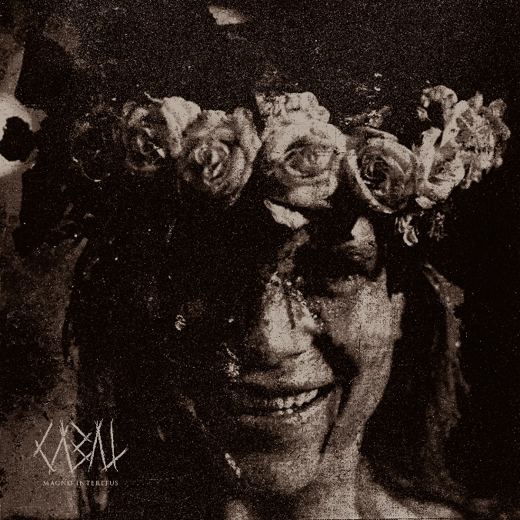

CABAL

»Magno Interitus«

OUT: October 21st2022
Line up: | CABAL online:
Andreas Bjulver Paarup – Vocals  Christian Hammer Mattesen - Guitars  Chris Kreutzfeldt - Guitars  Malthe Strøyer Sørensen - Bass  Nikolaj Kaae Kirk - Drums | www.cabalcult.com  www.facebook.com/cabalcph  www.instagram.com/cabalcph/

Hailing from the cold north of Denmark, CABAL unleash their dark force with Magno Interitus, the bands third studio album. Rooted in a wide array of musical influences ranging from black metal and hardcore, to death metal and modern deathcore, CABAL have cemented themselves as a band at the cutting edge of the extreme metal scene, ready to tear down all genre borders.
CABAL first emerged from the the shadows in 2016 as their first release Purge pushed the boundaries of the extreme metal scene in their homeland. Two years later, their debut album Mark of Rot ripped CABAL out of the Danish underground, establishing the band as an international act with a promising future. Soon after, the band began playing their first big festivals and toured through Europe, Japan and North America. But the cultists had bigger plans..
CABAL released their sophomore album Drag Me Down in 2020 - a dark descent into a personal hell brought to life by crushing instrumentals, an oppressive atmosphere and dark personal lyrics delivered with relentless intensity, while still leaving room for experimentation and expansion of CABAL’s signature sound. Drag Me Down took CABAL to new heights, as the shows got bigger and the attention of the music industry grew immensely.
With guest appearances on their previous albums from none other than Trivium’s Matt Heafy, Jamie Hails of Polaris, CJ McMahon from Thy Art is Murder and Filip Danielsson of Humanity’s Last Breath, CABAL no doubt have friends in every corner of the metal scene.
In the early winter of 2022, CABAL mark a new era with the release of Magno Interitus. Singer Andreas Bjulver Paarup says: “The main theme on the album is the great decay happening all around us. It seems that everything just falls apart in these days. This applies to politics, society in general as well as some personal things. We tried to translate the feelings that we have about the state of the world into music.”
CABAL are not only charting new territory with their visceral and doom-laden sound but are also moving out of the comforts of their dark, black and white signature aesthetic into bright colours inspired from Ari Asters latest masterpiece, ‘Midsommar’. Flowers, vines and eerie cultist May Queens are amongst the new visual elements that define the aesthetic of Magno Interitus.
Andreas, who is the art director and lyricist in the band, is excited about the new direction of the album: “We have a kind of base sound, our safe home. From there, we can experiment and try something new. On Magno Interitus we really left our comfort zone and went deeper into the details and extremes than ever before. You can hear it on the title track, as well as on the opener “If I Hang, Let Me Swing” or on “Exsanguination”. These are my personal three favourites on the album at the moment.”
Once more, CABAL brought in some extraordinary features on the album such as Joe ‘Bad’ Badolato of Fit For An Autopsy on Magno Interitus, as well as Simon Olsen from the Danish band BÆST on the track “Insidious”. This time around, CABAL also experimented with a completely different format by inviting the dark, industrial duo ‘John Cxnnor’ to co-create the very unique track “Blod af Mit”.
Magno Interitus was produced, mixed and mastered by the band’s own guitarist Chris Kreuzfeldt, who has also produced every CABAL release to date. The album is out on 21st of October through Nuclear Blast Records.
Catch CABAL on the road as they travel the globe to promote the release, and experience the band in their full form.

CABAL proudly endorse:
Meinl Cymbals
Trick Drums USA
Cosmic Ears
Aviator Guitars
Quantum Industries
Zilla Cabs

Record label: Nuclear Blast Records.
Management: Prime Collective.
EU Booking: Avocado Booking.
North American Booking: TKO Booking.

